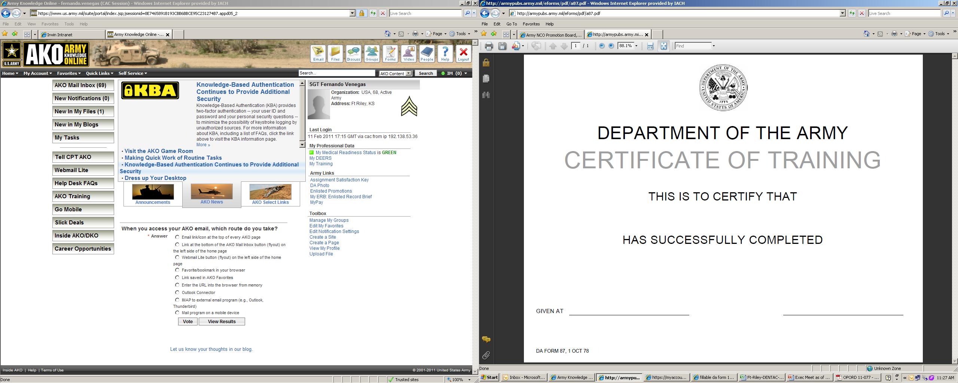

PFC George Bush

Instructor’s Name

The Class Info goes here

Your Info